## Technical instructions on how to run the SVVEHDEN study package

*25th of November, 2021*

Overview  
The SVVEHDEN study package (also known as the pharmacovigilance use case in work package 1) gathers information that can be used as a starting point in signal evaluation. The study package uses the regular OHDSI infrastructure with a CodeToRun-file, that calls an execute-function built into the study package. The package also relies on SQL to retrieve and aggregate data. The output consists of html-files, that are uploaded to the sftp-server, according to standard OHDSI practice.

The execution is based on running a for-loop over a set of drug-event-combinations (DEC), one at a time. From a patient data protection point of view, we also want to mention that if any cohorts for a DEC is of size less than 5 individuals, data extraction for that particular DEC is aborted and the for-loop moves to the next DEC.

## Setting up the repo

The SVVEHDEN-study package is hosted at <https://github.com/ohdsi-studies/SvvEhden>   
  
Use the master branch. After initiating the repo on a computer with access to the server where the OMOP data is hosted, open the project file within the repo in Rstudio, which should give you a screen similar to what’s displayed below:  
  
Build and install the study package  
To build and install the study package on your local computer, given that you have the necessary prerequisites for building R packages (see e.g. <https://support.rstudio.com/hc/en-us/articles/200486488-Developing-Packages-with-the-RStudio-IDE> ), you can either click the “Build” tab in the upper right panel, and select “Install and Restart” or press CONTROL + SHIFT + B.   
  
During building of the package, a log of the installation will appear in the upper right panel. If the package installs successfully, the log will end with DONE, as displayed below:  
  
  
Provide server connections, folders for file storing and uploading of results  
Next, read through the file “CodeToRun.R”, located in the extras-folder in the package.   
The comments in the file should be helpful for you to enter required information on how to connect to your server holding the OmopCdm-data, and where to store temporary files and output.   
  
At the end of the script, you are to enter information for uploading results to the sftp-folder. Please see the attached information provided in txt-files in previous email.  
  
Test run on the first DEC using synpuf  
Once the relevant information has been filled in, we recommend to test run the package on one DECs in synpuf before running on the full list of DECs. Apart from setting the cdmDatabaseSchema pointing towards synpuf-data, you can control the number of DECs by the maxNumberOfCombinations parameter, set to 1 in the CodeToRun.R file.   
  
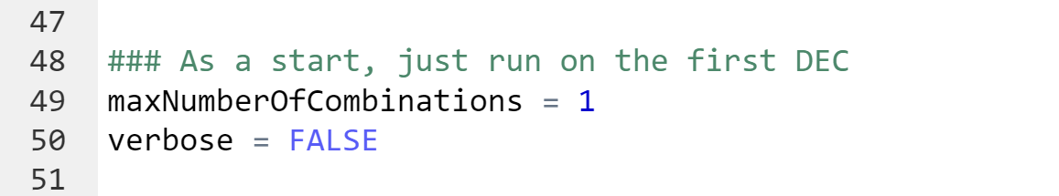  
  
When running the first DEC in our synpuf-evaluation, the execution time was approximately 2.5 hours.   
  
How to use the synpuf-version of the DEC-list  
There are two DEC-list provided with the study package that are relevant for you, one that’s based on what’s available in the so called Synpuf data (“fake_DEC_list.csv”, see screenshot below), and a second one that’s intended for use in the real longitudinal data (“minisprint_DEC_list_v4.csv”).

The choice of DEC-list is controlled by the cdmDatabaseSchema provided from you. If the cdmDatabaseSchema does not contain the word “synpuf” (case insensitive), the real DEC-list will be used. If your synpuf-data is stored in a cdmDatabaseSchema that does not contain this keyword, you can edit this on line 639 in the file “general_function_library.R” located in the R-folder, see the screenshot below. Remember to build and install the package, after any modifications of this script.   
  
Console printout messages as below (here executed on a small set of patients in Synpuf) indicates that the evaluation on synpuf is proceeding well.  
  
Running on the whole DEC-list  
If the synpuf test executes smoothly, you can start executing on the full DEC-list by changing the cdmDatabaseSchema to point to the real longitudinal data, setting maxNumberOfCombinations to NULL, and run CodeToRun.R.